Would We Know Alien Life If We Saw It?
And have we already seen it on Mars?
By Trudy E. Bell
Air & Space Magazine | Subscribe
April 2016

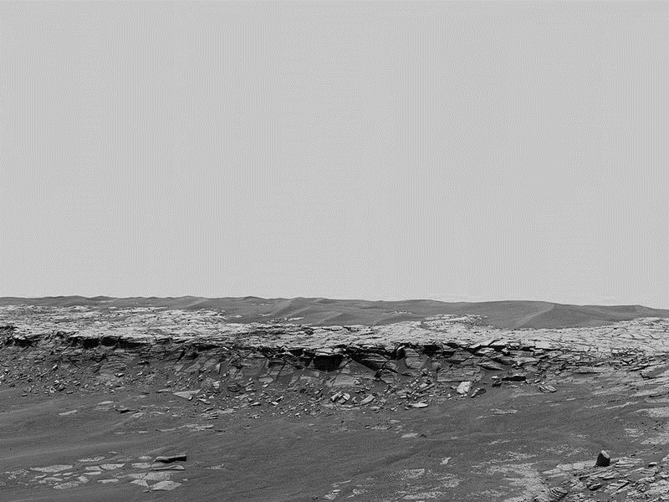
Scene from a desert planet: a panoramic view of the Payson outcrop near the Opportunity rover’s landing site. With its ocean long gone, Mars may yet have liquid reservoirs underground, and spacecraft have seen signs of surface flows. Life, if it ever existed, most likely followed the water. (NASA/JPL-Caltech/USGS/Cornell)
At this moment, seven robotic spacecraft are roving or orbiting Mars, taking photos, gathering data, and generally doing the bidding of scientists back on Earth. After 15 years of this continuous robotic presence, we know the Red Planet better than any world besides our own. And planetary scientists have an answer, finally, to one of their oldest and most fundamental questions: Could Mars support life?

The answer is yes: certainly in the past, and very possibly today. In 2013, less than a year after Curiosity touched down in the ancient lakebed Gale Crater, John Grotzinger, the project’s principal investigator, announced with confidence: “We have found a habitable environment,” one where substantial amounts of surface water existed billions of years ago. What’s more, the Curiosity science team is convinced that the lakes and streams lasted for long periods, perhaps millions of years.

Another announcement, just as momentous, followed last September: Water still flows on Mars today—at or very near the surface. For more than a decade, NASA’s strategy in exploring Mars has been to “follow the water”; the agency reasons that wherever there’s water, we might find life. Now, having made the case for water, space agencies are preparing to launch Mars missions whose primary purpose is to search for evidence of biology. And, unlike earlier searches, these missions have a real chance for success.

In the 1960s, the first generation of planetary scientists tried to come up with a single suite of instruments (for what became the 1976 Viking landers) that could settle definitively whether life exists on Mars. Ultimately, they failed. Scientists now suspect that past experiments in Martian biology asked questions that were too narrow or even wrong.

“Defining life is a problem,” explains Carol Cleland, a University of Colorado philosopher who has spent more than a decade examining the scientific and philosophical literature on the nature of life. “If your definition is wrong, you’ll look for the wrong thing—and be liable to miss all kinds of weird forms of life. Even today, we haven’t gotten away from an Aristotelian definition.”

More than 2,000 years ago, Aristotle defined living beings as those that metabolize (consume nutrients and eliminate waste) and sexually reproduce. That definition served well enough until the middle of the 20th century, when scientists learned about DNA and came to understand that the predominant life-form on Earth is the single-cell organism. (Indeed, complex multicellular life doesn’t appear in the fossil record until less than a billion years ago.)

Many single-cell creatures defy Aristotelian ideas about metabolism and reproduction. Some don’t consume organic nutrients at all. A bizarre marine microbe called Shewanella, for example, gets its metabolic energy by using “nanowires” that draw electrons directly from rocks. Some organisms don’t need sex to reproduce: They “fragment” directly from the parent. Still others act as if they’re alive at some times, dead at others. Viruses, for example, can lie dormant for centuries in a crystalline state.

In the past few decades, scientists have found many “extremophiles,” which survive quite nicely in environments once thought to be lethal: in superheated geysers, on the bottoms of Antarctic glaciers, in the crushing blackness of the deep ocean.

If terrestrial life has turned out to be far stranger and more adaptable than we once thought, how much weirder could it be in an alien biosphere like Mars?

Yet there’s reason to hope we’ll find familiar organisms too. “The argument for water-based and carbon-based life is never stronger than on Mars,” says David Des Marais, principal investigator of space science and astrobiology at NASA’s Ames Research Center in California. “Some folks like to speculate that solvents other than water might also support life,” he notes. “While one can never absolutely deny the possibility of ‘weird life’ based on an alternative solvent, water is particularly favorable for Mars because the environment of Earth has been more similar to that of Mars than that of any other planet in our solar system.”

Since we have to start somewhere, Des Marais and others argue that we should look for familiar forms of life first; we can worry about the life-forms we don’t know later. “Pick your best shot” for success, he says.

Read more at https://www.airspacemag.com/space/life-in-universe-special-what-is-life-180958432/#BSx2dTqqJug1fGDl.99

