What is Herd Immunity?
By Emily Willingham and Laura Helft
Posted 09.05.14 NOVA
The term "herd immunity" refers to a means of protecting a whole community from disease by immunizing a critical mass of its populace. Vaccination protects more than just the vaccinated person. By breaking the chain of an infection's transmission, vaccination can also protect people who haven't been immunized. But to work, this protection requires that a certain percentage of people in a community be vaccinated. What factors determine where that critical-mass threshold lies? And once it's in place, how does herd immunity cocoon the most vulnerable among us?

What is "herd immunity?"
Just as a herd of cattle or sheep uses sheer numbers to protect its members from predators, herd immunity protects a community from infectious diseases by virtue of the sheer numbers of people immune to such diseases. The more members of a human "herd" who are immune to a given disease, the better protected the whole populace will be from an outbreak of that disease.
There are two ways an individual can become immune to an infectious disease: by becoming infected with the pathogen that causes it or by being vaccinated against it. Because vaccines induce immunity without causing illness, they are a comparatively safe and effective way to fill a community with disease-resistant people. These vaccinated individuals have protected themselves from disease. But, in turn, they are also protecting members of the community who cannot be vaccinated, preventing the chain of disease from reaching them and limiting potential outbreaks. Every vaccinated person adds to the effectiveness of this community-level protection.

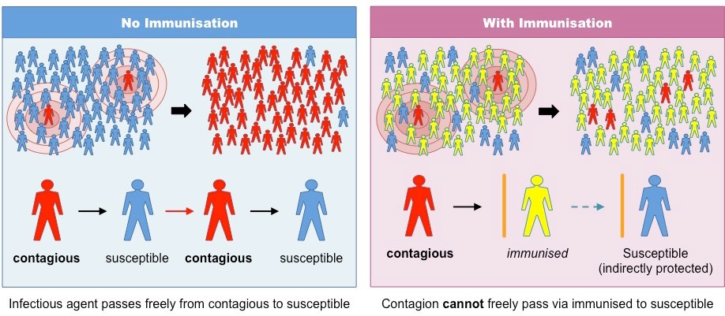
Herd, or community, immunity is the result of a high immunization rate. Photo credit: The National Institute of Allergy and Infectious Disease (NIAID)

What do thresholds have to do with herd immunity?
The microbes that cause disease all have different infectious features. Some, like measles and influenza, pass from person to person more easily than others. Some tend to have more severe consequences in specific demographic groups. For example, the symptoms of pertussis, or whooping cough, are distressing at any age but can be fatal in infants, the age group with the highest death rate from pertussis. Each of these features—such as transmissibility and severity—affects a given disease's threshold, or the minimum percentage of immune individuals a community needs to prevent an outbreak.
To set a threshold, epidemiologists—experts in infectious disease transmission—use a value called "basic reproduction number," often referred to as "R0." This number represents how many people in an unprotected population one infected person could pass the disease along to. For example, R0 for measles is between 12 and 18, while for polio, it is between five and seve. The higher this number is, the higher the immunity threshold must be to protect the community. Because measles is extremely contagious and can spread through the air, for example, the immunity threshold needed to protect a community is high, at 95%. Diseases like polio, which are a little less contagious, have a lower threshold—80% to 85% in the case of polio.
The general concept of an immunity threshold seems simple, but the factors involved in calculating a specific threshold are complex. These factors include how effective the vaccine for a given disease is, how long-lasting immunity is from both vaccination and infection, and which populations form critical links in transmission of the disease. The collective differences in these factors result in different thresholds for different diseases (see below), with a significant factor being R0.

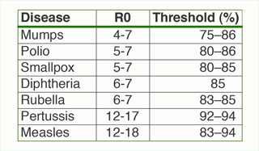
Relationship between R0 and threshold level needed for herd immunity. Photo credit: © Tangled Bank Studios; data from Epidemiologic Reviews 1993.

Why is herd immunity important?
Human communities were once relatively small and isolated. Diseases certainly broke out, but their transmission ended wherever geography limited a populace's mobility. But today, our chains of connection traverse the globe—reaching across oceans and over mountain ranges, pervading immense cities and remote villages—linking us all into one vast, interactive human herd. Almost no one anymore lives in isolation from such connections.
These chains of human interaction have resulted in more potent chains of disease transmission. The only thing that can break a chain of transmission is a disease-resistant link. The chicken pox vaccine offers an example of the effectiveness of disease-resistant links. After the chicken pox vaccine debuted in the United States in 1995, deaths rates from chicken pox dropped by as much as 97%. Significantly, even though the vaccine is not administered to infants, no infants died from chicken pox in the United States between 2004 and 2007. These tiniest, most vulnerable links in the chain of human connections avoided exposure thanks to herd immunity.

