[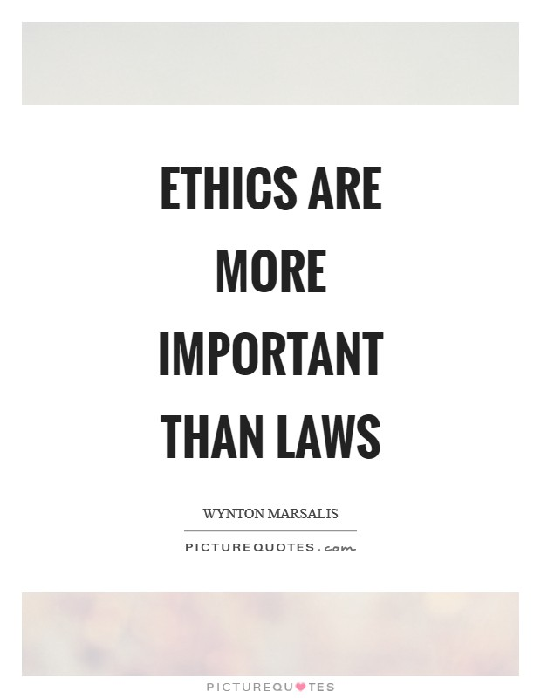](https://www.google.com/url?sa=i&rct=j&q=&esrc=s&source=images&cd=&cad=rja&uact=8&ved=0ahUKEwiLvvuT3-nYAhVLX60KHTyTDp8QjRwIBw&url=http%3A%2F%2Fwww.picturequotes.com%2Fwynton-marsalis-quotes&psig=AOvVaw3jqkt9nn8YGzbfVhmyZEte&ust=1516647697978370)

What does this quote mean to you?

[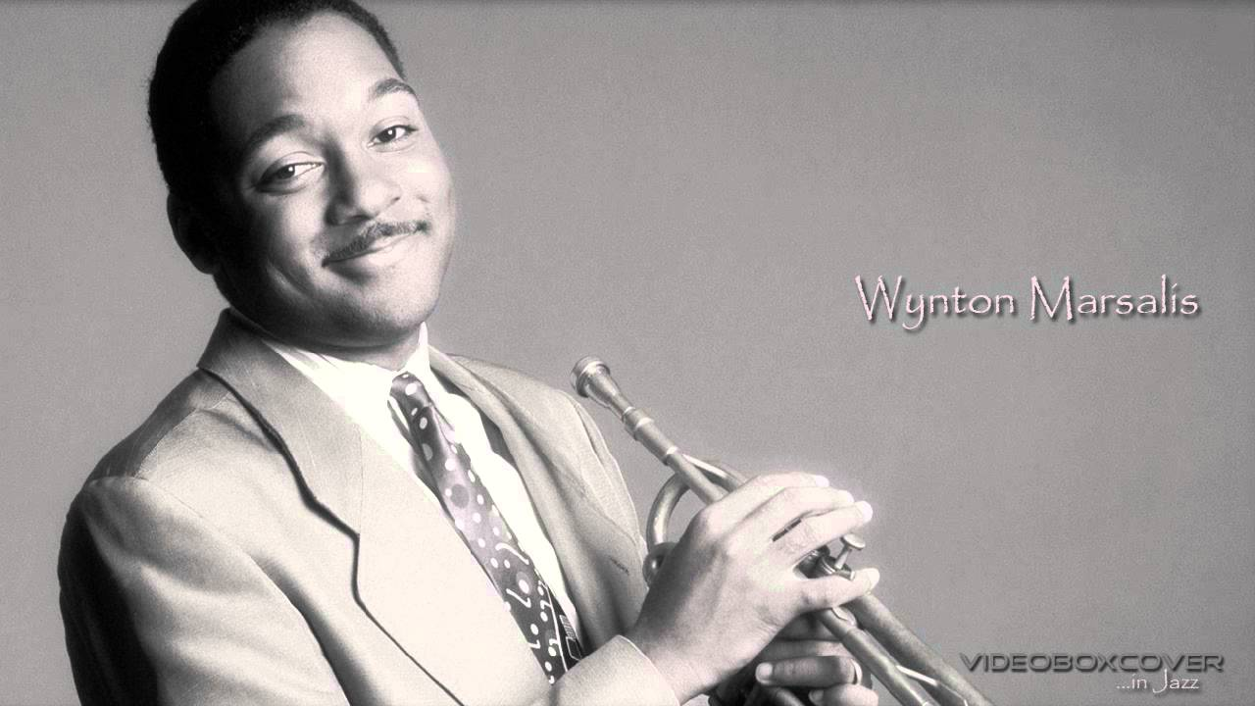](https://www.google.com/url?sa=i&rct=j&q=&esrc=s&source=images&cd=&cad=rja&uact=8&ved=0ahUKEwjoye-73-nYAhVQKawKHZf-DoYQjRwIBw&url=https%3A%2F%2Fwww.youtube.com%2Fwatch%3Fv%3DaRRUCkbM8NE&psig=AOvVaw3dmH5DLnMk0Wqsm1t7FbOK&ust=1516647789002123)