Rethinking Herbal Medicine
A phylogenetic study of traditional plant remedies could aid drug development.
By Beth Marie Mole | September 10, 2012

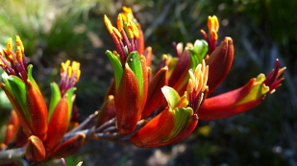
The medicinal New Zealand flax (Phormium sp.). Phormium species are used traditionally by Maori people to treat a wide range of conditions, including skin, respiratory and gastro-intestinal problems.
University of Warwick, United Kingdom, Andrew Clarke

Many scientists raise a skeptical eyebrow to traditional herbal treatments, but a new phylogenetic study suggests that such remedies may hold promise—for both medicine and drug development.

In the study, researchers from the University of Reading in the United Kingdom found that many medicinal plants used by nearly 100 cultures on different continents are related. Because these distant groups of people likely identified their plant therapies independently, such herbal treatments may be legit, the researchers argue, and the plants likely contain bioactive compounds that scientist could exploit for new drug therapies.

“People think there’s nothing new to be found,” said John Beutler, a leading chemist at the National Cancer Institute’s Center for Cancer Research, who was not involved in the study. “But, that’s just not true. Wherever we look, we find new stuff.” But critics still doubt whether researchers will be able to sort effective traditional remedies from the bogus ones, and whether pharmaceutical endeavors will follow.

In previous studies that tried to use cultural comparisons to find useful remedies, scientists struggled to make meaningful taxonomic comparisons. “If [local] floras are different, obviously plants that are used in traditional medicine will be different,” said Royal Botanic Gardens Kew postdoc Haris Saslis-Lagoudakis, lead author of the study, which was published today (September 10) in the Proceedings of the National Academies of Science. But Haris and his colleagues’ phylogenetic comparisons allowed them to link seemingly unrelated plants.
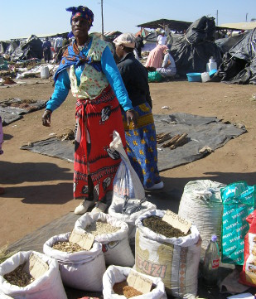
They constructed genus-level phylogenetic trees of plants from 3 disparate locations—New Zealand, Nepal, and the Cape of South Africa. Once they assembled their trees, they overlaid ethnobotanical data regarding the therapeutic uses of various plants by cultures from each of the three locations (one culture from New Zealand, three cultures from The Cape of South Africa, and more than 80 cultures from Nepal).

In the flora phylogenies for each of the three continents, medicinal plants clustered into “hot nodes,” meaning they were more related to each other than the other plants in the analysis. Further, categorizing medicinal plants by what condition they treated, the researchers found that medicinal plants clustered into condition-specific nodes, even when the analyses from all three locations were combined—again suggesting a high degree of relatedness for plants used to treat similar conditions and lending some validity to these herbal treatments.
A plant trader selling medicinal plants at the Mona Market, KwaZulu-Natal, South Africa.
Credit: Natural History Museum of Denmark, Copenhagen, Denmark, Gary Stafford

Biomedical researchers have occasionally drawn from ethnobotany and traditional treatments when looking for new drugs, but the use of this strategy has waned in recent decades. Though more than 80 percent of plant species have not been tested for therapeutic potential, the last major drug discovered from plants was the cancer drug Taxol in 1967.

This lack of interest stems, in part, from skepticism about the legitimacy of traditional plant therapies. Many cultures use medicinal plants for multiple ailments, for example. If a plant is good for your stomach, people may start taking it for problems with their nearby liver, then their lungs, then their heart and head, and so on, said Daniel Moerman, a professor emeritus of the University of Michigan-Dearborn and a leading expert on ethnobotany and cross-cultural studies. This makes it difficult to determine what condition a medicinal plant may effectively treat.
Haris, who recently completed his PhD at the University of Reading, sidestepped the issue by accounting for all the documented conditions each plant treated. “We scored everything—all of the uses that are defined—and let the results speak for themselves.”

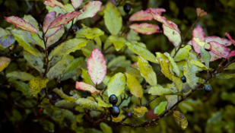
Pseudowintera colorata, a plant species used medicinally in New Zealand. Pseudowintera species are used traditionally by Maori people to treat skin conditions, respiratory problems, and to help heal wounds.
Credit: Manaaki Whenua Landcare Research, Lincoln, New Zealand, Steven Wagstaff

Another criticism facing the study is that cultures sometimes use symbolic visual cues to identify potentially disease-treating plants. For example, it may be common for traditional healers to treat menstrual symptoms with plants that have red flowers, explains evolutionary biologist and senior researcher on the study Julie Hawkins. Such appearance-based selection would suggest that relatedness of medicinal plants is due to looks, not bioactivity.

“But, we’re finding a lot of morphological variation amongst [related medicinal plants],” Hawkins said, which suggests that visual cues don't explain their relatedness.

The researchers also looked at plants being developed or already in use as drug therapies around the globe and found a significant number fell in the nodes with the traditional medicinal plants, further supporting the validity of the method in identifying plants useful for drug discovery. The team noted several plant genera related to traditional medicinal plants that have not been tested for bioactivity, which could serve as low-hanging fruit in the search for new therapies.

Both Beutler and Moerman expressed skepticism, however, that pharmaceutical companies would jump at the new approach to guiding their drug discovery, as the industry has largely shifted toward robotic, high-throughput screens of chemical libraries. But new approaches are always welcome, Beutler said. “The perception is that we’re doing the same old grind and find, and it’s just not the case.”

