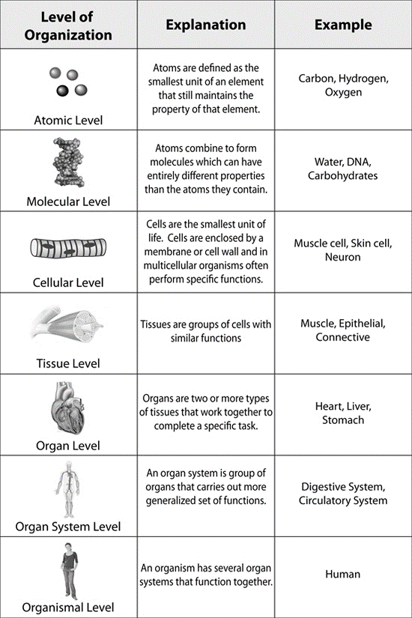
Atoms assemble to form molecules, molecules assemble to form cells, etc.
So at what point do we consider something alive? Why?

