10 times scientists genetically modified animals and came up with some weird results

http://www.businessinsider.com/genetically-modified-animal-experiments-2015-10

Tanya Lewis

Oct. 17, 2015, 2:34 PM

Frankenstein may be a work of fiction, but these experiments are real.
For decades, scientists have been tweaking the genes of animals to give them desirable (and sometimes just plain bizarre) traits. This is possible thanks to gene editing techniques that make it possible to easily cut and paste DNA.
Here are some of the weird and wacky experiments researchers have done on animals over the years. Could humans be next?

Dolly the sheep
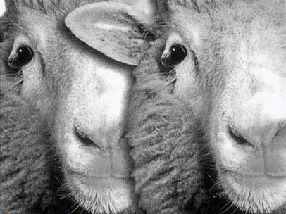
Flickr/Amanda Parsons
In 1996, British scientists created the first cloned sheep, named Dolly, by transferring the nucleus from an adult cell into an unfertilized premature egg whose nucleus had been removed, a process called nuclear transfer. Sadly, Dolly died of a lung disease at the age of six.

Glow-in-the-dark mice
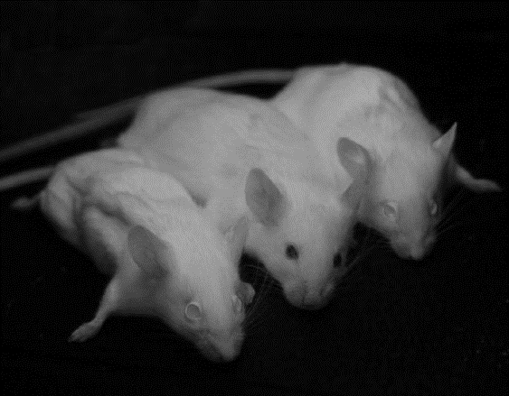
Ingrid Moenet et al, 2012

And in 2002, scientists at Caltech created glow-in-the-dark mice by injecting single-celled mouse embryos with a virus that contained a jellyfish gene for green fluorescence. Researchers have since created glow-in-the-dark fish,cats, and other animals.

Less farty cows
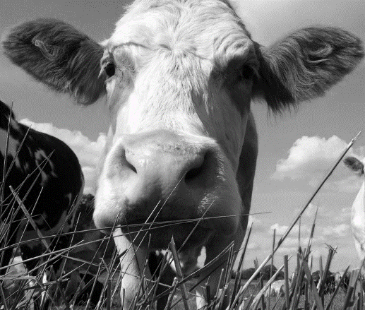
Flickr/Amanda Parsons

Some of these experiments serve a noble purpose. Researchers at the University of Alberta in Canada found the bacterium that produces methane, and in 2009, they created a line of cattle that produces 25% less of the smelly gas than the average cow. This is important because methane from cows is a major source of the greenhouse gases causing global warming.

Silk-spinning goats
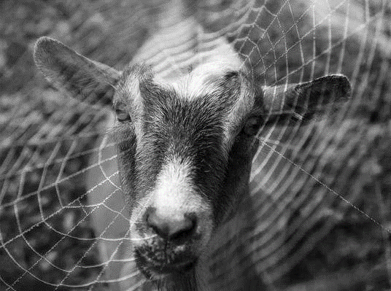
National Science Foundation

In 2012, scientists at the University of Wyoming engineered goats to produce a protein in spider silk in their milk. Silk is useful for a variety of applications in materials science and medicine, and it's hard to get spiders to make enough of it.

Allergy-free milk
Flickr / hjhipster

That same year, AgResearch, a company owned by the New Zealand government, engineered a cow to produce milk without one of the proteins that many people are allergic too, known as β-lactoglobulin. The milk also contained more casein, a nutritious protein found in milk.

GMO salmon
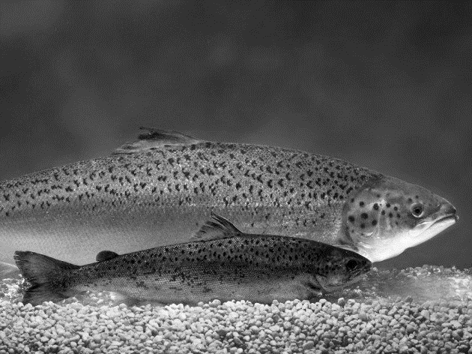
AquaBounty Technologies

AquAvantage salmon (background) and regular Atlantic salmon (foreground).
And soon, we could be eating genetically modified animals. The AquAdvantage(R) Salmon, created by a company called AquaBounty Technologies, contains a gene from the Chinook salmon that makes it grow much faster. The salmon is currently under review by the FDA.

Super-muscly pigs
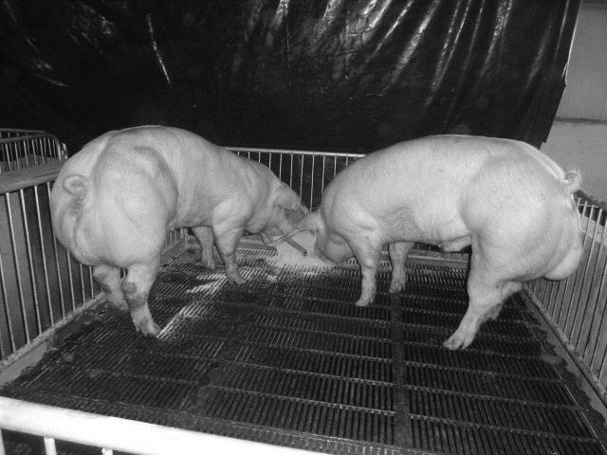
Jin-Soo Kim

In the last few years, researchers have found ways to edit genes much more easily and accurately. Earlier this year, South Korean scientists used a gene editing technology called a TALEN to tweak the genes in pigs to make them produce more muscle, Nature News reported.

Tiny pet 'micropigs'
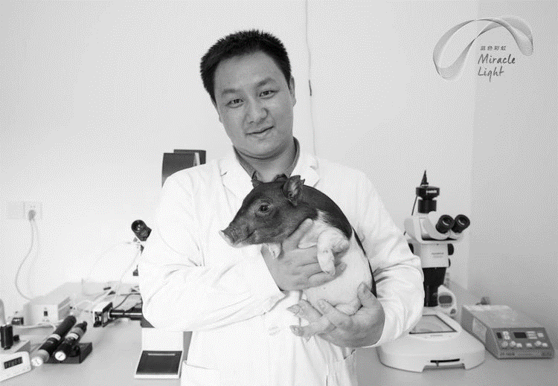
BGI

We might even start to have genetically modified pets. Scientists in China used a new genome editing technique called CRISPR/Cas9 to modify the genes of Bama pigs to create tiny "micropigs" which they plan to sell commercially. The feat stirs up a larger debate over how this powerful method should be used.

Pig organ donors
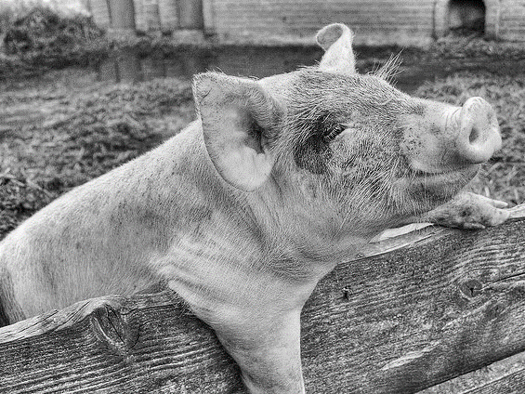
Flickr

Gene editing technology could also revolutionize medicine. Geneticist George Church of Harvard University and his colleagues recently modified more than 60 genes in pig embryos, in an effort to make the animals suitable donors for human organ transplants. That's ten times the number of genes that scientists have edited in any other animal, Nature News reported.

GFP bunny
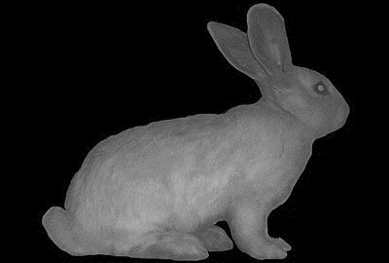
Eduardo Kac

But scientists aren't the only ones doing these experiments. In 2000, an artist named Eduardo Kac created a glow-in-the-dark bunny, known as the "GFP bunny," an albino rabbit that fluoresced under blue light.

